|  |
| --- |
| Justin Tools Basket |
| Installation and User Guide |
| Justin Luo |

Contents

About the software 3

1. Installation steps 3

1.1 Double click the file Setup.exe in the .zip installation file. 3

1.2 Click Install button. 3

1.3 Find the icon in your start-up menu or desktop. 3

2. How to use it for a job: 4

2.1 Introduction of main interface 4

2.1.1 Main interface 4

2.1.2 Excel BOM File Location: 4

2.1.3 CNC Library Location: 4

2.1.4 Excel BOM information: 5

2.2 Search CNC files directly from the Library for a job 5

2.2.1 Input all the information in the main interface. 5

2.2.2 Search and Copy from Library 5

2.2.3 Open Excel BOM file. 6

2.2.4 Check whether you have gotten all the part CNC programs (optional) 7

2.2.5 Add Printing Label to All CNC Files 7

2.2.6 Load all the parts program files to nest 8

2.3 Use an existing nest file as template for a job 8

2.3.1 Copy the template to job folder and input all the information in the main interface. 8

2.3.2 Search Job folder Only Firstly 8

2.3.3 Search in Library Secondly 9

2.3.4 Open Excel BOM file. 9

2.3.5 Add Printing Label to All CNC Files 10

2.3.6 Replace all the CNC files with value “Not Found” in Column L in the nest file. 10

2.4 Print a standard manufacturing package. 10

2.4.1 Input the location and other information of the Excel BOM file. 11

2.4.2 Choose the printer. 11

2.4.3 Print the package. 11

3. Maintain the Library 12

3.1 Delete program file and keep the old file with affix “-Rev00i” 12

3.2 Move CNC program files with certain text in name to job folder. 13

3.3 Copy CNC program files with certain text in name to job folder 13

3.4 Add hyperlink to excel BOM file cells for part name. 14

3.4.1 Case 1: Add *.dwg file link to USA dwg drawings and its BOM 14

3.4.2 Case 2: Add DXF file hyperlinks to Canada Excel BOM 15

3.4.3 Case 3: Create a file list for all the files in a folder. 15

4. For Help 16

# About the software

This software help CNC programmer to find all the existing CNC programs in library for a job automatically and copy them into a job folder. Then, CNC programmers can load all the programs from this folder to nest them together without searching them in the library one by one manually. It also contains small tools to add printing labels to the CNC program files, print PDF drawing packages, and add PDF file links to the part drawings in the Excel BOM.

# 1. Installation steps

## 1.1 Double click the file Setup.exe in the .zip installation file.

## 1.2 Click Install button.

## 1.3 Find the icon in your start-up menu or desktop.

# 2. How to use it for a job:

## 2.1 Introduction of main interface

### 2.1.1 Main interface

On the bottom of the interface, the left side is status bar that shows text information of current task, and the right side is a progress bar. They will change according to your task status.

### 2.1.2 Excel BOM File Location:



You can copy the path name directly into the text box, or use **Find BOM File button** to find the location.

### 2.1.3 CNC Library Location:



You can copy the path name directly into the text box, or use **Find CNC Library button** to find the location. It is where you save your existing standard program files.

### 2.1.4 Excel BOM information:

L=12

H=8

Offset=4

## 2.2 Search CNC files directly from the Library for a job

### 2.2.1 Input all the information in the main interface.

Input the location of excel BOM file, Job folder where you want to copy CNC files to, and CNC library location.

### 2.2.2 Search and Copy from Library

After input all the information, Click **Search and Copy button**. The software will search CNC files for parts listed in Excel BOM. For a part, it will search in job folder firstly. If a CNC file is found in the job folder, the software will skip searching, and will begin to search for the next part in the list. If a CNC file is not found in job folder, it will search in library folder, and will copy matching CNC file in library to Job folder.

### 2.2.3 Open Excel BOM file.

Click **Open Excel File button** to open the Excel BOM file. You will find a column has been added in the BOM file. In column M, some cells contain CNC file path names, and some cells contain “new” and its back color changed to orange. The part with “new” in column M is the one that there is no existing CNC file for it in the library. The cell with label “new” has a hyperlink to the drawing’s DXF file. Click on the cell, it will open the DXF file in your CNC program editor. Create CNC programs for the part and saved them in job folder. Please remember to save new programs whose name with standard affix into your library as well. So, you do not need to create them again for the next job when this part is used again.

### 2.2.4 Check whether you have gotten all the part CNC programs (optional)

Click **“Search Job folder Only button**”. The software will search CNC files in your job folder only. Open Excel file. If “Exist” is shown in the column “L” for some parts, it means their CNC programs have been founded. If “Not found” with Red back color is shown in the column “L” for some parts, it means their CNC programs have not been founded. You need to create one for it. Graphical user interface, table

If all the parts have “Exist” in the column “L”, it means that you can start to nest them for this package.

### 2.2.5 Add Printing Label to All CNC Files

Click tab “Label”, and input the project information into the highlighted textbox, and then click “**Add Button**”. The information in the textbox will be added to all the CNC files in the job folder.

### 2.2.6 Load all the parts program files to nest

In your CNC programming editor, you can load all the part CNC programs for this job from the job folder to nest.

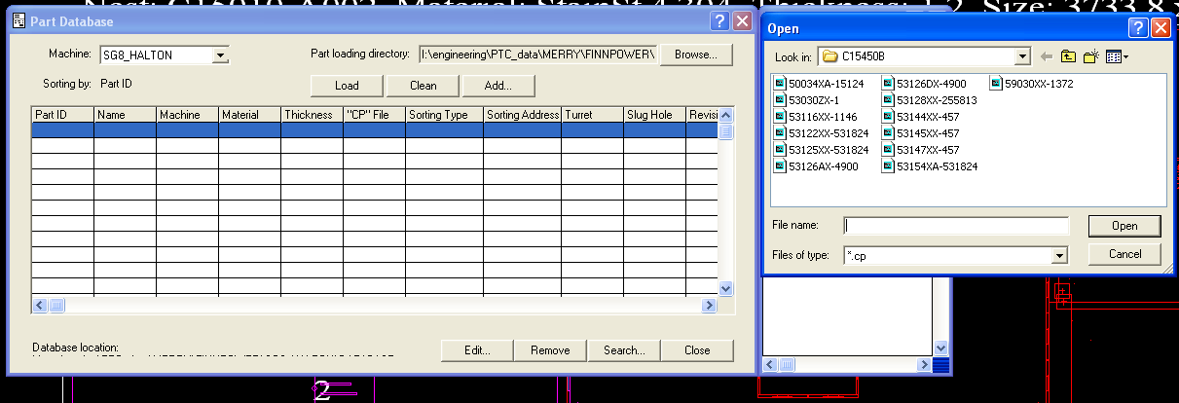

## 2.3 Use an existing nest file as template for a job

### 2.3.1 Copy the template to job folder and input all the information in the main interface.

Find a recent nest file that the product sizes are close or same as current job, so most of the parts are in the same size. Copy the existing nest file into the job folder, and all the CNC files in the nest file will also be copied to the job folder.

Input the location of excel BOM file, Job folder where you want to copy CNC files to, and CNC library location.

### 2.3.2 Search Job folder Only Firstly

After input all the information, Click **“Search Job folder Only button**”. The software will search CNC files for parts listed in Excel BOM in job folder.

### 2.3.3 Search in Library Secondly

Click “**Search and Copy button**”.

### 2.3.4 Open Excel BOM file.

Click **Open Excel File button** to open the Excel BOM file. You will find 2 columns has been added in the BOM file.

In column L, some cells’ values are “Exist” means the parts’ CNC file are the same as existing nest files. Some cells’ values are “Not Found” with red back color means that the parts are different from the ones in the existing nest file, and you need to replace them with new program files.

In column M, some cells’ values are CNC file path names, and some cells’ values are “new” with orange back color. The parts with “new” in column M are the ones that there are no existing CNC files for them in the library. The cell with label “new” has a hyperlink to the drawing’s DXF file. Click on the cell, it will open the DXF file in your CNC program editor. Create CNC programs for the part and saved them in job folder. Please remember to save new programs whose name with standard affix into your library as well. So, you do not need to create them again for the next job when this part is used again.

### 2.3.5 Add Printing Label to All CNC Files

Click tab “Label”, and input the project information into the highlighted textbox, and then click “**Add Button**”. The information in the textbox will be added to all the CNC files in the job folder.

### 2.3.6 Replace all the CNC files with value “Not Found” in Column L in the nest file.

Open the Excel file, and find all the cells with value “Not Found” in red back color in the column L. Then replace them in the nest file one by one. All the new CNC files have already been in the job folder. This way can save programmer’s time to nest parts.

## 2.4 Print a standard manufacturing package.

For some standard product, there are normally no changes for every release. CNC programmer have already input the PDF CNC file name in column H in the Excel BOM file.

For example, this is a BOM for a control panel with C7 screen, 1 PLC with size 15 X 24.

### 2.4.1 Input the location and other information of the Excel BOM file.

### 2.4.2 Choose the printer.

### 2.4.3 Print the package.

Click “Print **Button**”. If you check the “Only Print First Page”, it will only print first page of every PDF drawing file. If you uncheck the “Only Print First Page”, it will print all pages of every PDF drawing file. In our PDF drawing file, there are normally 2 pages. The first one is the main drawing with 4 views. The second one is for the Flat pattern of the sheet metal part. Normally, we do not want to print the second page.

After click “**Print Button**”, we can get the whole package. First paper is the Excel BOM. Second paper is the main assembly drawing. Then, all the part drawings in the same sequence in the BOM file. The last several papers are CNC files.

# 3. Maintain the Library

## 3.1 Delete program file and keep the old file with affix “-Rev00i”

After engineers modify the design of a part, all the CNC program files in the library for this part need to be deleted. Current working program file will be saved as a file whose name carry latest revision number.

For example, 50034XX is a collar part. If an engineer decides to change the top flange width from 1 inch to 1.5 inches from now on. He needs to tell CNC programmer to delete programs for all sizes of collars in database. These files’ names contain text “50034XX” and different affix based on the sizes, such as “50034XX-1211”, “50034XX-1214”, “50034XX-810”, “50034XX-1213”, and so on.

All programs for a part should be saved in one folder in your library. For example, CNC programmer Tao in Canada have built a part folder “50034” in database, and he put all the program files whose name contain “50034” in this folder. When the software tries to delete all the files that contain “50034XX” in database, and it finds one file “50034XX-1211” in the folder of “50034”, it will assume all the other files whose names contain “50034XX” are in this folder. For example, 50034XX-1211-Rev001 and 50034XX-1214 should be in this folder. Software will not continue to search other folders for them, and just search in this folder. This is a precondition for this software, and it can save searching time for us.

After clicking” **Delete CNC Files in Library button** “, while checking the “**Delete the Files Checkbox**”, there is message box popping out and “**DeletFilesList.txt**” is shown in notepad. Follow the instruction in the message box to delete or cancel the deleting.

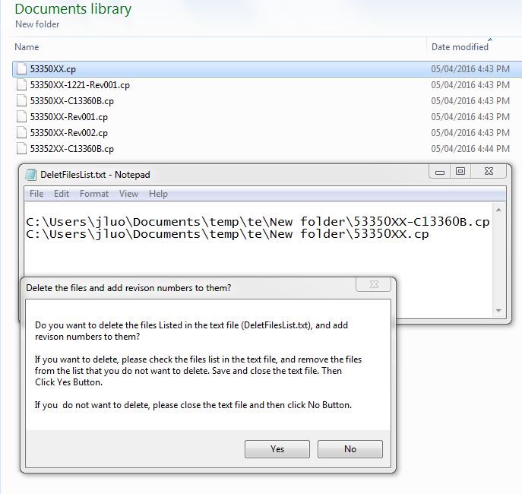

|  |  |
| --- | --- |
|  |  |
| Before deleting | After deleting |

## 3.2 Move CNC program files with certain text in name to job folder.

When some parts are not used any more, their CNC programs should be removed from database. You can click **To Job Folder button** while checking the checkbox. All the program files whose names contain the certain text in Textbox will be moved to job folder. The software does not delete the files directly, because I want to give you a last chance to check whether you want to delete these programs. In this case, the job folder is like a recycle bin. You can keep the files there for a while, and check the programs there, then manually delete them by yourself.

## 3.3 Copy CNC program files with certain text in name to job folder

When you click **To Job Folder button** while **unchecking** the checkbox, software only copy the program files whose names contain the certain text in Textbox to job folder, and does not delete the ones in library. When you do not have an excel BOM file to provide the program files searching list, you can use this function to search and copy program file from database one by one. In this case, please input the whole file name with extension (50034XX-1211.cp) into the textbox, and so the software will only copy this file; otherwise, it may copy this file’s old revision version (50034XX-1211-Rev001.cp) as well.

## 3.4 Add hyperlink to excel BOM file cells for part name.

It can add hyperlink to excel file cells. The hyperlink is linked to a file whose file name is the same as the cell value, and with the file extension specified by you. The file is also saved in the same folder as the excel file.

When you have a excel file which is a BOM of a job or a product, it can help you to find the drawing quickly.

### 3.4.1 Case 1: Add *.dwg file link to USA dwg drawings and its BOM

I got *.dwg drawings for KMH hood from USA engineering manager Aaron. There are more than 100 drawings in the folder, and they are for different configurations of hood. There is also a excel file which contain the drawing number and its description inside the folder. From the description, I can find a part drawing.

I can use this tool to create hyperlink in the excel file. Inside the column where save the part names, the software tries to find the corresponding DWG drawing for each of the cells. If it can find, it will add a hyperlink to the cell. Then you can open a dwg drawing directly by click the cell. If the software cannot find the drawing, there is no link on the cell. So, you will not waste time to search for a non-existing file.

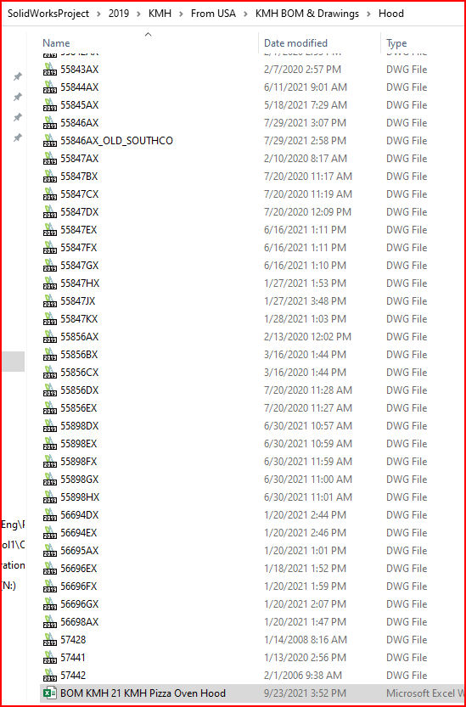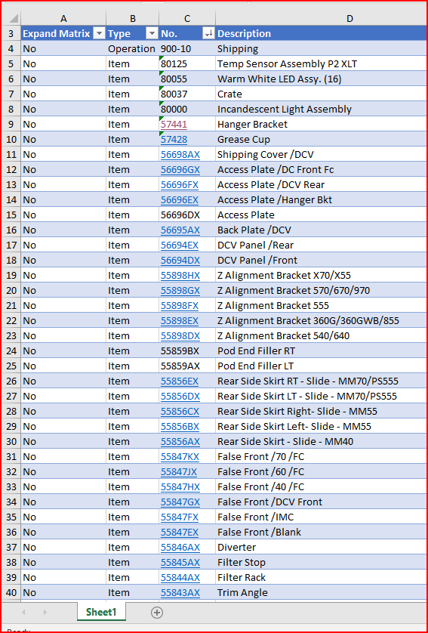

### 3.4.2 Case 2: Add DXF file hyperlinks to Canada Excel BOM

Add DXF files’ hyperlink to the part names in the Canada Excel BOM, and set the DXF file default openning application as CNC programming editor in CNC programmer’s computer. When CNC programmers click the part Numbers with “new” in column M, the DXF files will be openned in the CNC programming editor directly. It can save time for him and avoid picking up the wrong DXF files.

### 3.4.3 Case 3: Create a file list for all the files in a folder.

When you get many DWG drawings for a job without a BOM, you can create a excel file and create a file list with hyperlinks in the excel file automatically by click “**Create List in Excel Button**”.

For example, I got a DWG drawing package from USA for CFA hood “H-1L Closures 96L 51H”. I create an Excel file “H-1L96L51H-BOM.XLSX” for this package.

# 4. For Help

While opening this software, press key “F1”, this document will be opened.

If you have any questions about this software, please email to [Justin.luo@halton.com](mailto:Justin.luo@halton.com).